**NODES:**

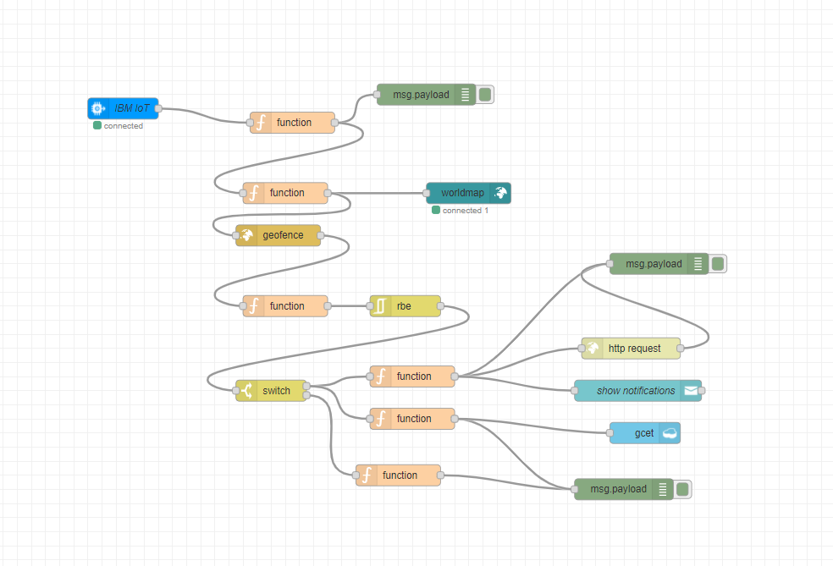

**OUTPUT AT DEBUG CONSOLE :**

**OUTPUT FOR IN LOCATION:** 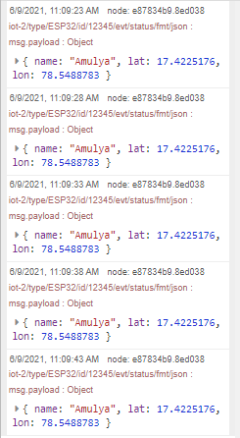

**OUTPUT FOR OUT LOCATION:**